1. This program allows the user to pick between two options to plot their data, in the form of a bar graph or pie chart. The user would input 1 for a bar graph, and 2 for a pie chart. After selecting one of the two options, the user will then be asked to input the necessary data, starting with the title. In the case of the bar graph, the user would input the x axis label, followed by the categories that would go along the x axis. The user would then have to input the corresponding data to those categories in the exact order that the categories were entered in. The program would then ask for the y axis label as well as the increment that the y axis should increase by. Finally, The program will provide the user with their selected graph/chart with the data plotted in. The program uses numpy so that the data is accepted as arrays, allowing the user to input all the categories or corresponding data at once. The matplot library is used to plot the data within a bar graph or pie chart.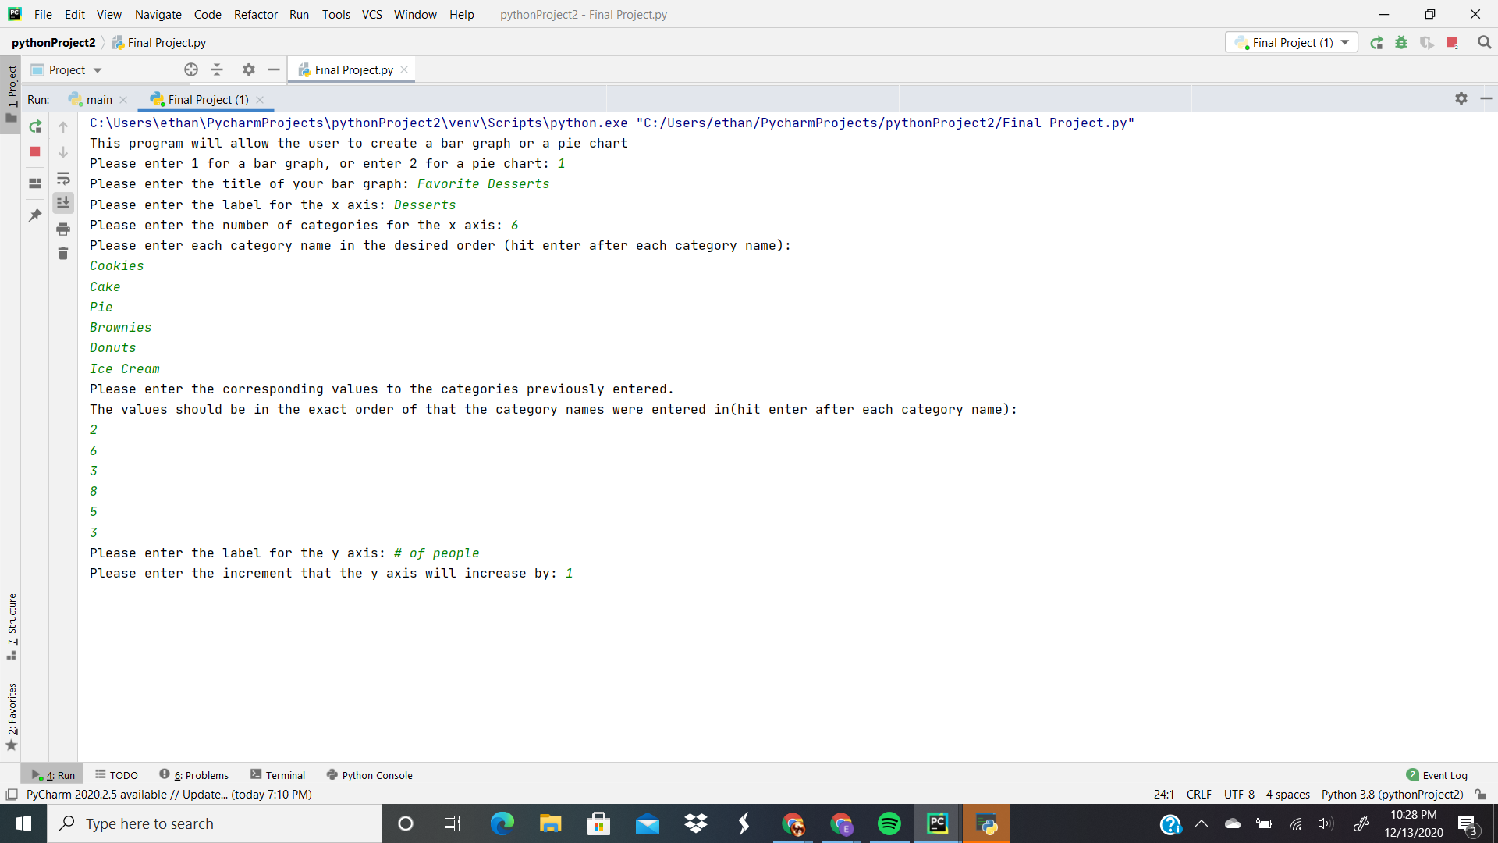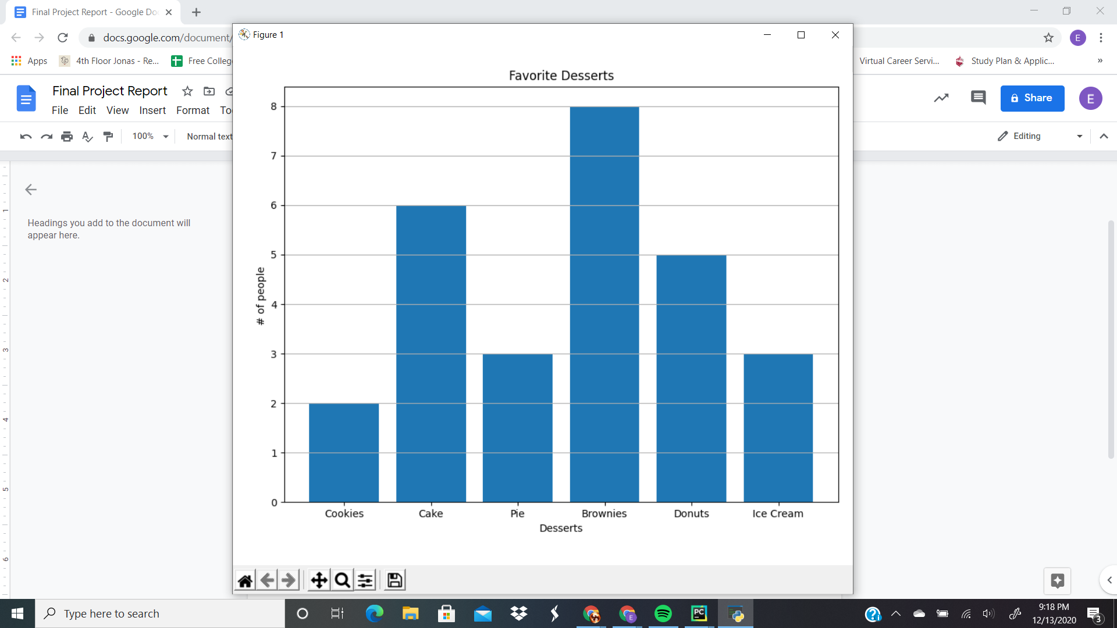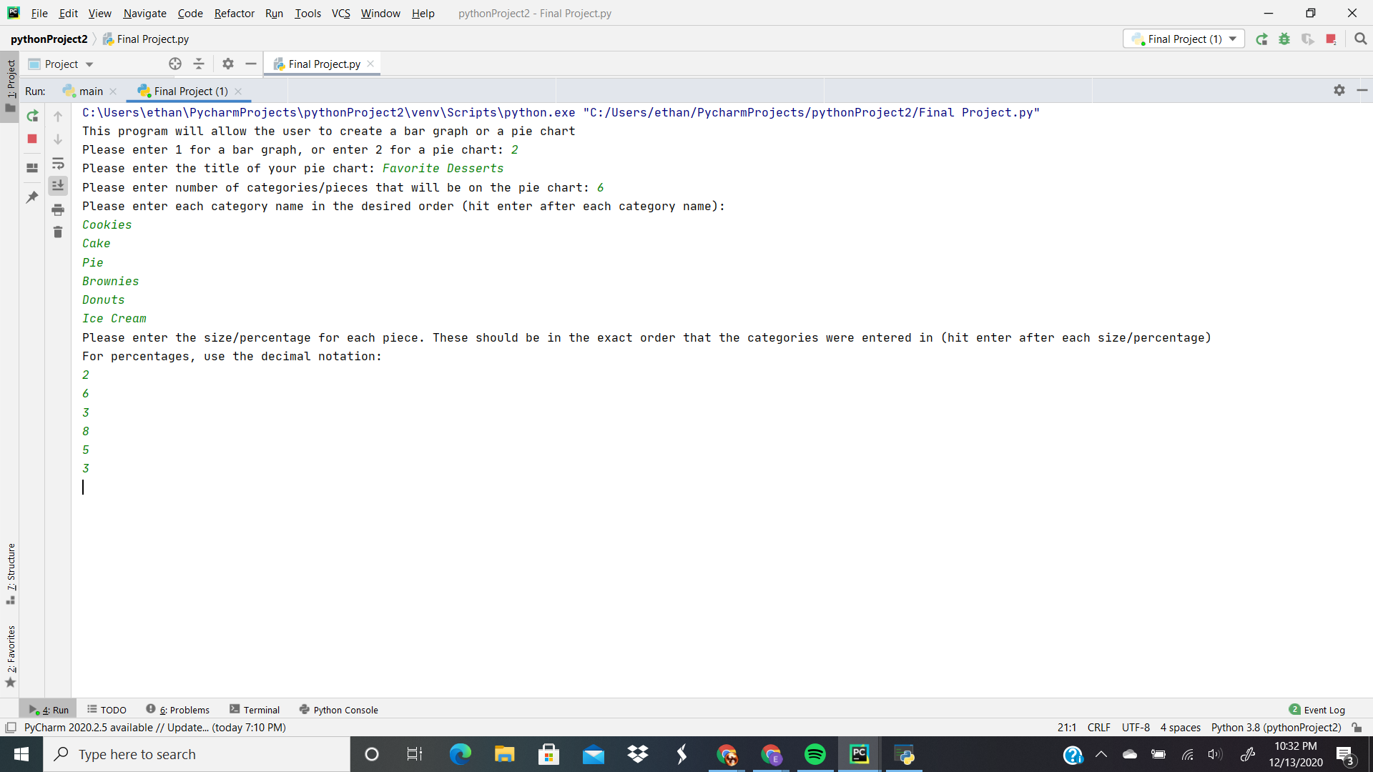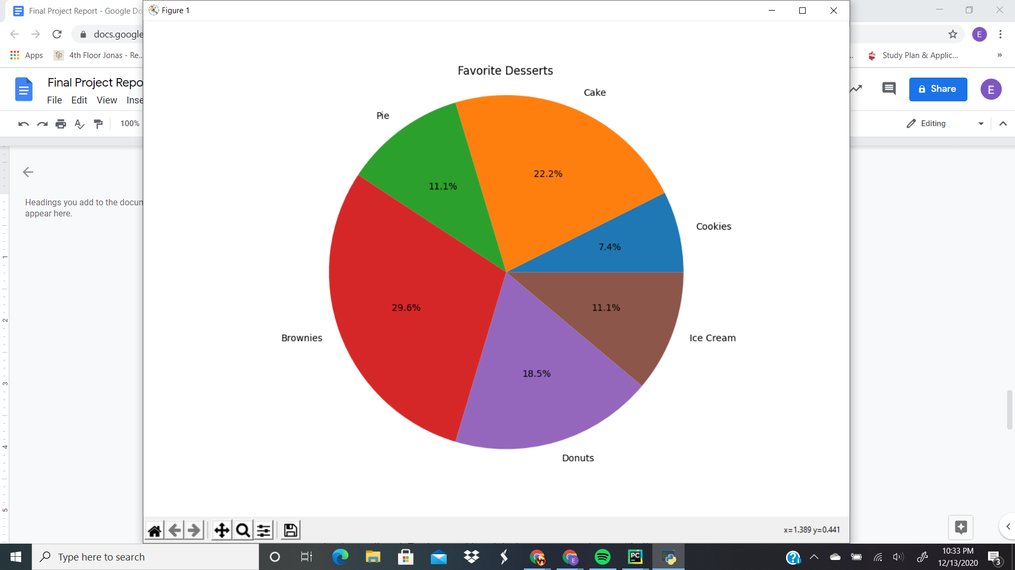
2. This program works for anyone looking to graph/plot some data. This could be a student, teacher, or business analyst. Students would have most likely surveyed a small sample of people, and would then use this program to graph that data to view and process the info they have collected. Teachers would use it in the same manner, but specifically survey students about something related to the subject they teach, or ask for improvements at the end of the year. Business analysts would receive their data from another department, and then would use this program to understand what the data means.
3. The libraries used were numpy and matplotlib. Numpy was needed so that the data could be put into arrays. Matplotlib was very much needed, as the basis of the program is to graph data, so it was responsible for a majority of the program. For loops were used to allow the user to continually enter any data that was related to the prompt(categories and corresponding data). Within these loops, lists were used and added to using the append function. An elif statement was used to ask the user to pick an option, and would respond accordingly if the user inputted something acceptable or unacceptable.
4. More often than not, I had my variables mixed up and would use an incorrect variable where a different one was needed. For example, I accidentally reused my xcat variable, which was supposed to be the list for my categories, and appended the corresponding data to that same list. This returned a tick label error, and I was unable to figure out how to solve this issue since I did not recognize it. After looking through my program multiple times, I was able to identify the error and change it to the correct variable, so that when the user inputted their corresponding data, it would append to the catval list. The bar graph part of the program proved to be more difficult, as I was able to finish the pie chart portion relatively quickly without many issues.
5. The program can be updated to include more kinds of graphs/charts, such as line graphs, scatter plots, and histograms, just to name a few. The program could also include a while loop so that when a user selects an invalid option, the program will ask them to reselect so that the user can continue use of the program without having to restart. Some more specific upgrades would be allowing the bar chart to accept increments greater than one, as it is currently unable to do that. The bar chart could also include different colors for each bar. The user interface could be upgraded to be more user friendly.